**Revien Jay E. Baterina**

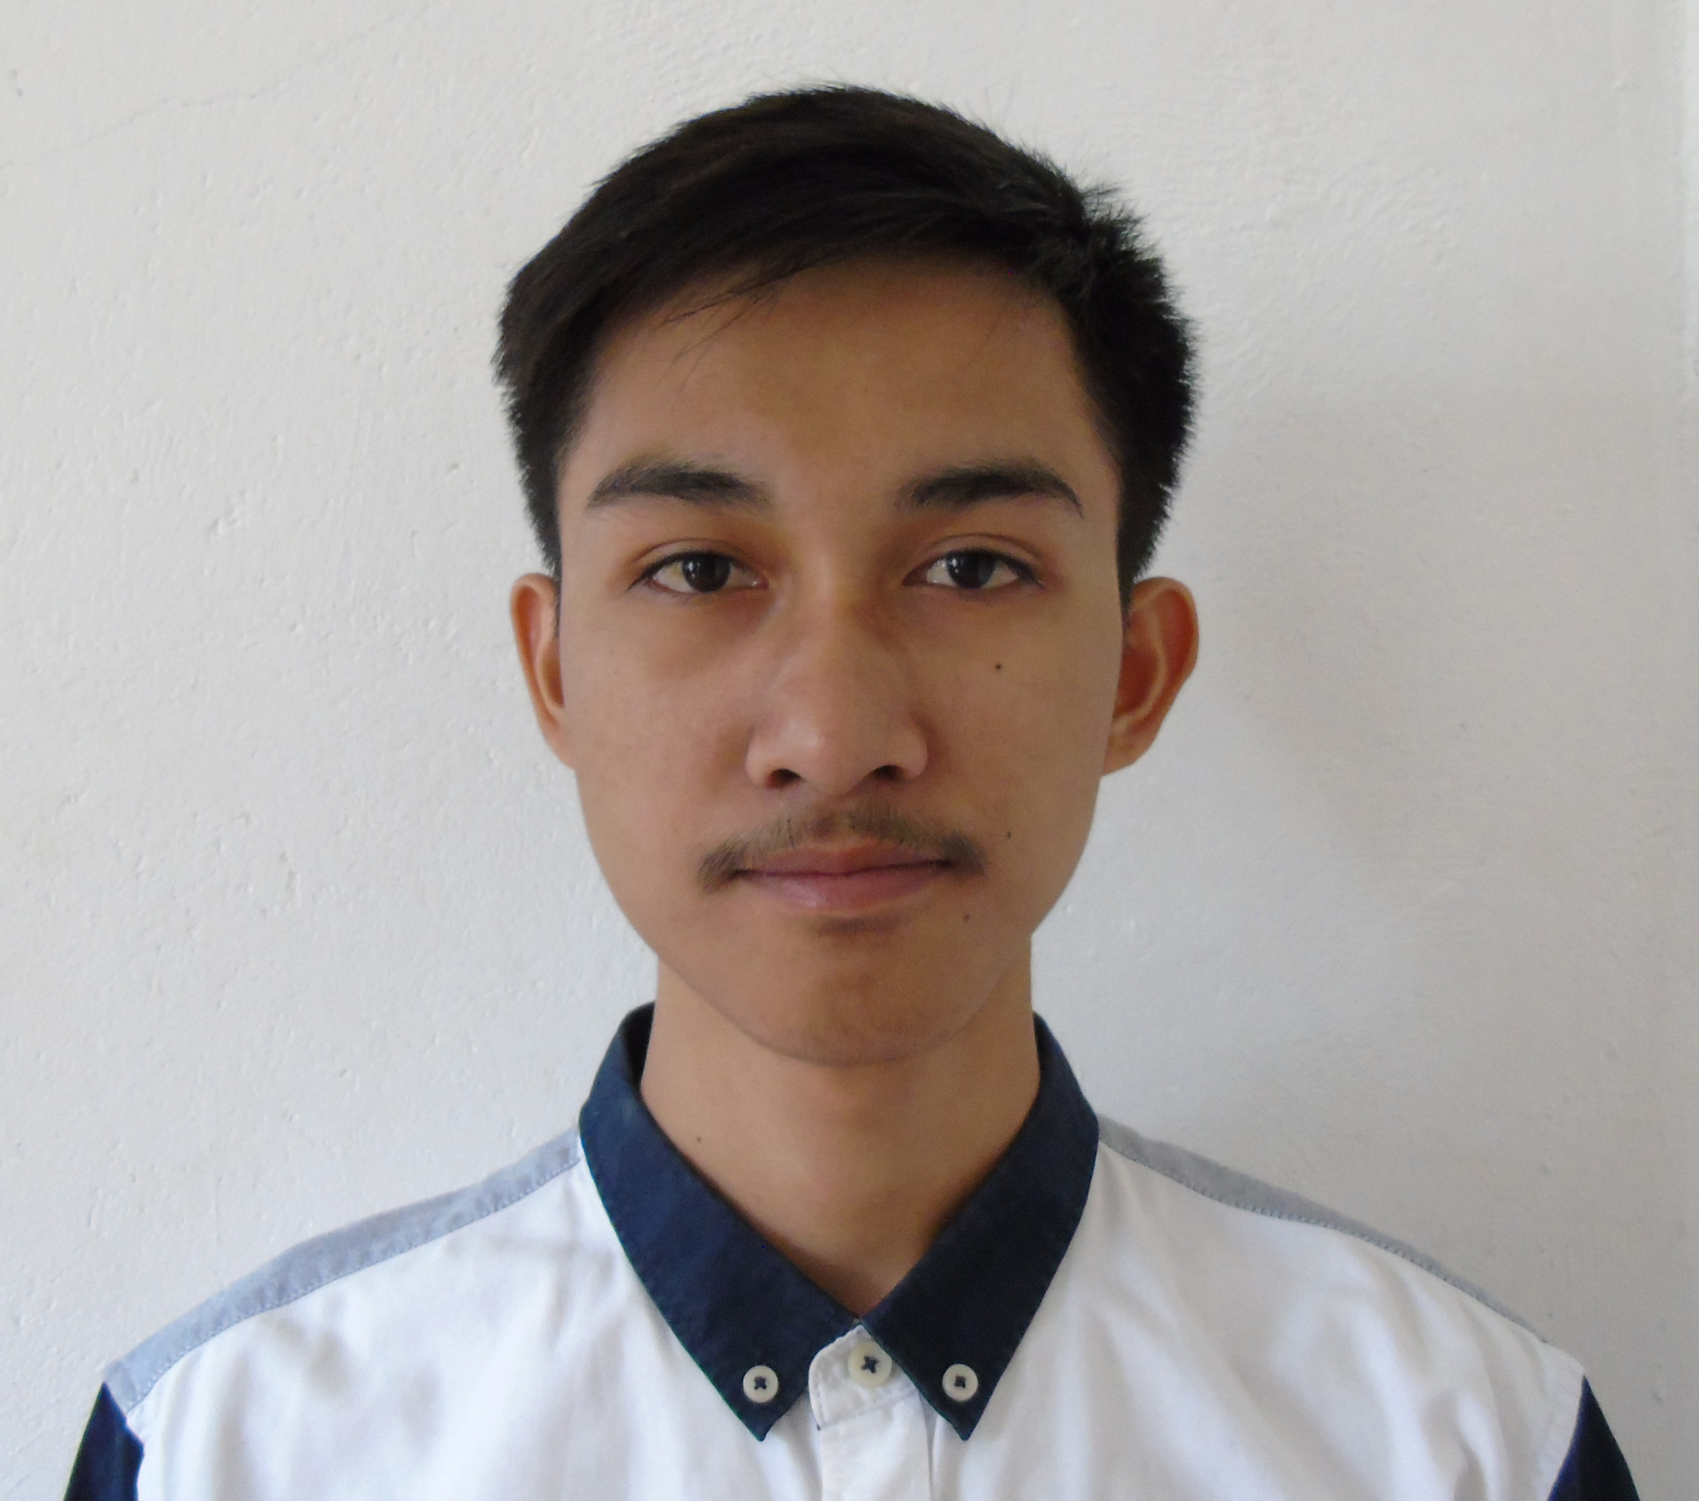

**Pinmilapil, Sison, Pangasinan**

**Contact #:** 09954557682

**Email:** [rjhaybaterina12@gmail.com](mailto:rjhaybaterina12@gmail.com)

**OBJECTIVES:**

To obtain an entry-level computer programmer position in a fast-paced organization where I can utilize experience in logical thinking skills and developing software to provide the company with excellent software solutions.

**SEMINARS AND TRAININGS:**

* GDG DevFest Baguio 2017

“Open Source Web Development and Mobile Application Development”

November 11, 2017

University of Cordilleras Baguio City

* College of Computing Week Seminar 2017

“Empowering people and innovation in Computing towards ASEAN Globalization”

March 31, 2017

Pangasinan State University-Urdaneta Campus

Urdaneta City, Pangasinan

* IT Internship

“Developed an Information System for the company called (Employee Attendance Report System)”

Feb. 14, 2019 to Apr. 10, 2019

Professional Regulation Commission Baguio City

**PROJECTS:**

* **Online Public Access Catalogue (using PHP and Mysql)**
* **Appointment Medical Record System (using JQuery, AJAX, PHP and Mysql)**
* **Online Event Reservation and Organizing System (using Bootstrap, JQuery, AJAX, PHP and Mysql)**
* **Attendance Report System for PRC Baguio (Desktop Application using c# .Net, Microsoft Access, Crystal Report)**
* **Online Quiz and Examination System (using ASP.Net C#, MSSQL, JQuery, Bootstrap, AJAX)**

**(BASIC)SKILLS/QUALIFICATION:**

* Programming Languages: JAVASCRIPT, PHP, ASP.Net, C#, VISUAL BASIC
* Database Experience: Microsoft Access, SQL Server, MySQL, MS SQL Server
* Web development experience using OOP, PHP, AJAX, JAVASCRIPT, JQUERY, ASP.Net, XML, BOOTSTRAP, HTML and CSS
* MS Office (MS Word, MS Excel, MS Powerpoint)

**PERSONAL INFORMATION:**

Gender : Male

Date of Birth : November 12, 1998

Civil Status : Single

Citizenship : Filipino

Religion : Iglesia Ni Cristo

Mother’s Name : Rowena E. Baterina

Occupation : OFW

Father’s Name : Rodolfo B. Baterina JR.

Occupation : Auto Mechanic

**EDUCATIONAL BACKGROUND :**

**Tertiary:**

**Course:** BS Information Technology

**Name of School:** Pangasinan State University Urdaneta City Campus

**Address of School:** San Vicente, Urdaneta City Pangasinan

**Year Graduated:** 2019

**Secondary:**

**Name of School:** Bantay Insik Integrated School

**Address:** Bantay Insik Sison, Pangasinan

**Year Graduated:** 2015

**Primary:**

**Name of School:** Pinmilapil Elementary School

**Address:** Pimilapil Sison, Pangasinan

**Year Graduated:** 2011

**CHARACTER REFERENCES:**

* Michael E. Acosta

IT Department Chair(PSU-Urdaneta)

+639957918731

* Kristin Bhing Salvio

IT Instructor(PSU-Urdaneta)

+639471612601